**PROFILE OF FACULTY MEMBERS**

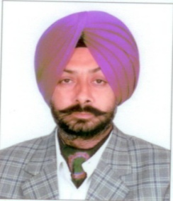

1. Name: **Er. JASMINIDER SINGH GREWAL**

2. Date of Birth: 23/05/1969

3. Educational Qualifications

|  |  |  |
| --- | --- | --- |
| S.No. | Qualifications | Passing Year |
| 1 | Ph.D. | Pursuing |
| 2 | M.E. | Dec 1999 |
| 3 | B.E. | June 1991 |

4. Professional Memberships: Life member of ISME and ISTE

5. Work Experience

* Teaching: 19
* Research: 10
* Industry: 01
* Others: Nil

6. Designation: Associate Professor

7. Additional Duties:

* **Head Workshops**
* President Sports
* Chairman student grievance committee
* Worked as Dean Training and placement for five years

8. Area of Specializations: Manufacturing Processes, Metallurgy, Metal Forming, Mechanics of Materials and Engineering Drawing

9. Subjects Taught: Engineering Drawing and Graphics, Strength of Materials, Metal Forming, Manufacturing Processes.

10. Research Guidance

Master’s:Guided:

|  |  |  |  |
| --- | --- | --- | --- |
| S.No. | Name of the Student | Title | Year of Submission |
| 1. | Rupinder Singh | Enviromental Management System Design Implementation in cement industry | March 2001 |
| 2. | Nripjit | Implementation of Inventory control using material requirement planning(MRP-I) system(A case Study) | April 2000 |
| 3. | Anil Kumar | Comparative Study of the process output parameters of Die steels EN-24 and HcHCr using Aluminium and Copper electrodes | Feb 2002 |
| 4. | Kuldip Rai | Study on Weld properties of Aluminium welded by MIG Welding process | May 2002 |
| 5. | Darshan Singh | Study of Wire Electric Discharge Machining(WEDM) output parameters on EN-24,EN-31 and HcHCr Steels | Aug 2002 |
| 6. | Gurmeet Kaur | An experiment study of Bead Geometry in Gas metal Arc Welding | March 2004 |
| 7. | Naib Singh | Optimization of Spot Welding control parameters for Low Carbon Steel by Taguchi Technique | July 2004 |
| 8. | Vaishali Goyal | Influence of Welding parameters on Tensile shear streangth and Nusset diameter of resistance spot wells on Cold rolled sheet of low Carbon steel | July 2004 |
| 9. | Sanjeev Kumar | Tig Welding of Aluminium Boffler plates for Head-Ex Changer | Dec 2005 |
| 10. | Munish Chhabra | Weldability study of Austenitic Stainless Steel(AIAI-304) with pulse GMAW | Sept 2006 |
| 11. | Ravinderpal Singh | Protection of Boiler Tubes against Hot Corrosion using HVOF sprayed Ni-Al Coatings | Dec 2006 |
| 12. | Tarik Moyerro | Comparative study of the performance of Cryo-treated and Nano coated drills in dry drilling | May 2009 |
| 13. | Arunesh Mangla | To study the effect of varying composition of Chromium(0.6%-35%) in Hard facing Alloys on wear, hardness and microstructure | March 2010 |
| 14. | Jwala P. Singla | To study the effect of thermally sprayed coatings on wear rate of Grey Cast Irons | March 2010 |
| 15. | Rakesh Goyal | Enhancement of wear resistance of Carbon Steel with the application of Thermal spray coatings | March 2010 |
| 16. | Gaurav Prashar | High Temperature Erosion of Aluminium oxide coated Boiler tubes in Simulated coal fired boiles’s conditions | September 2010 |
| 17. | Vinod Pandita | To investigate the risk factors for the prevalence of Musculoskeletal symptoms and to find work related musculoskeletal disorders among steel plant workers | Pursuing |
| 18. | Kanwal Gurpreet Singh | To improve the wear life of slideways of the lathe machine | Pursuing |
| 19. | Sachin Raichan | Study of high temperature erosion of boiler steel tubes | Pursuing |

Ph.D: Nil

11. Projects Carried Out with Industry: Nil

12. Consultancy and Training: Nil

13. Patents: Nil

14. Technology Transfer: Nil

15. Research Publications: Nil

No. of Papers published in

* National Journals: Nil
* International Journals:- Nil
* International conferences:- 01
* National:- 09

Details:

National

|  |
| --- |
| 1. Seehra R.S,Bains H.S,Grewal J.S “ Shotpeening as surface corrective process” Ninth ISME conference on Mech.Engg. at University of Roorkee,Roorkee on 10-11 Nov,1994. 2. Tayal Nalin,Tayal S.P,Grewal J.S “ Quality Improvement in technical Institutions to meet the challenges of the industry” national conference on TQM in Technical Institutions, MACT(REC) Bhopal on 21-22 Dec,1996 3. Grewal J.S,Sharma N.D, Singh Jasdeep “Optimization of machining parameters using Geometric Programming” 16th National conference of Mech. Engineers and All India seminar on future trends in Mech. Engg. University of Roorkee,Roorkee on 29-30 Sept,2000. 4. Grewal J.S,Nripjit, Bhullar R.S “Designing the element of a material requirement planning(MRP-I) system in a make to order company” National conference at Coiambatore on 14-15 May 2001 5. Grewal J.S.Kaur Gurmeet “Some studies on back-bead geometry of mild steel using automatic GMAW process” National conference at SLIET Longowal on 18-19 Jan 2004 6. Grewal J.S,Singh Rupinder ”Spot Welding optimization of low carbon steel using Taguchi Technique” 2nd National conference on recen development in Mech.Engg. at TIET ,Patiala on 10-11 Nov 2006 7. Grewal J.S,Grewal C.S “ Nanotechnology:- The way for novelty in every stream of technology” National conference on Nanotechnology at Bhai Maha Singh College of Engg.,Muktsar on 23-24 Feb 2007 8. Grewal J.S, Singh Sehijpal,Chawla Vikas,Mangla A.K, “Improvement in abrasive wear resistance by Hardfacing: A Review” National conference on Advancement and Futuristic trends in Mech. and Materials Engg.(AFTMME’10) at Yadavindra college of Engg.,Talwandi Sabo on 19-20 Feb-10 9. Grewal J.S, ,Chawla Vikas,Singla J.P, “A survey of the Detonation Gun sprayed wear resistant coatings” National conference on Advancement and Futuristic trends in Mech. and Materials Engg.(AFTMME’10) at Yadavindra college of Engg.,Talwandi Sabo on 19-20 Feb-10 |

International

|  |
| --- |
| Singh Rupinder,Khamba J.S,Grewal J.S “Machining characteristics optimization using Taguchi Technique in ultrasonic drilling of Titanium alloys” International conference on Emerging Technologies in intelligent system and control(EISCO-2005) on 5 to 7 Jan, 2005 at Kumaraguru college of technology,Coimbotore |

16. Courses attended:

Details:

|  |
| --- |
| 1. Short term course on “*An integrated approach to flexible Automated Manufacturing*” held at College of Technology and Agriculture Engg. Udaipur from 01 July to 14 July 2000 2. Short term course on “*Mechatronics: Application ;Motion control and process control* ” held at GNDEC, Ludhiana from 17 to 28 July 2000 3. Short term course on “*A workshop o system Modeling and SIMULATION”* held at Sant Longowal Institute of Engg. And Tech, Sangrur from 31 July to 11 Aug. 2000 4. Short term course on “*Productivity enhancement through resource waste reduction”* held at Thapar Institute of Engg. And Tech, Patiala from 18 to 29 Dec 2000 5. One day Workshop on *“iNTELLECTUAL PROPERTY RIGHTS AND PATENTING ”* held at GNDEC, in collaboration with Waterfalls Institute of Technology Transfer New Delhi on 03 March,2006 6. One day Workshop on “*Patent Awareness Workshop”* held at Rayat & Bahra Institute of Engg. And Tech. on 9th Dec.2006 7. Short term course on “*Intellectual property rights and Patents systems in India*” held at NITTR, Chd. 18 Dec to 21 July 2006 8. Short term course on *“EDUCATIONAL AUDITING AND FEEDBACK SYSTEMS FOR EXCELLENCE IN TECHNICAL INSTITUTIONS”* held at GNDEC, Ludhiana in collaboration with NITTR Chandigarh from 12 January, 2009 to 16 January, 2009. 9. Short term course on *“MICROCONTROLLERS AND THEIR INDUSTRIAL APPLICATIONS”* held at GNDEC, Ludhiana on 31 Dec,1999 |

17. Expert Talk Delivered: Nil

18. Awards and recognition: Nil

19. No. of Books Published with details: Nil

20. Additional Information: Reviewed a book on engineering Drawing and Graphics of Tata McGrawhill

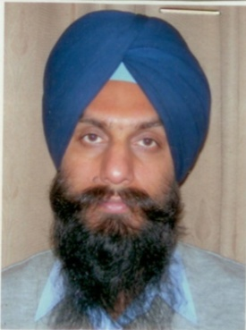

Name : Ranjit Singh

Date of Birth : 10-6-1971

Designation : Asstt. Prof. (Workshops)

Experience : Teaching : 16 years

Industry : 7 years

Other : worked as O.I/c. electrical

maintenance for 8 years

along with teaching.

Qualifications : M.Tech. (Electrical Engineering)

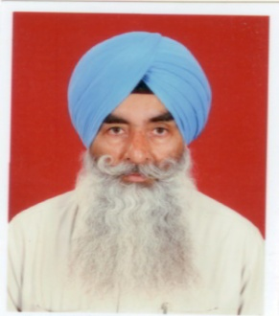

Name : Avtar Singh Grewal

Date of Birth : 21/09/1955

Designation : Sr.Instructor

Experience : 1.Instructor(16.7.1979 to till date)

2.Machinest Pearl Mech.Engg.&Foundry Works,Ldh(1976-1978)

Qualifications : 1.C.T.I.(1979)

2.I.T.I.(1976)

3.Matric(1973)

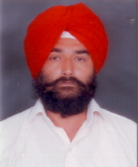

Name : Jasbir Singh

Date of Birth : 01-06-1966

Designation : Sr.Instructor

Experience : 1.Instructor(18.10.1992 to till date)

2.Supdervisor at Indian Decorator 366,Janta

Nagar(1986-1992)

Qualifications : 1.Diploma(1985)

2.Matric(1982)

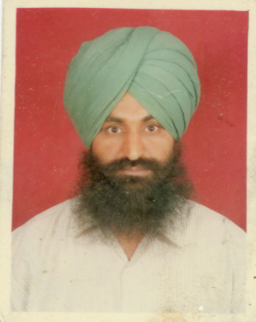

Name : Rampartap Singh

Date of Birth : 26-02-1966

Designation : Sr.Instructor

Experience : 1.Instructor(G.N.D.E.C.)(01.10.1992 to

31.12.1992 & 23.4.1993 to till date)

2.Industrial Expereince(1986-1992)

Qualifications : 1.I.T.I.Moulder(1986)

2.Matric(1982)

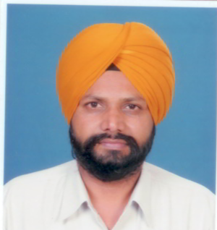

Name : Hakam Singh

Date of Birth : 18-02-1966

Designation : Sr.Instructor

Experience :1. Instructor(G.N.D.E.C.)(April 1994 to

Till date)

2.CDRT G.N.D.Poly.Ldh. (1990-1994)

Qualifications : 1.Post Diploma in Automobile & Tractor

Engg.(1991)

2.Diploma(1990)

3.Matric(1984)

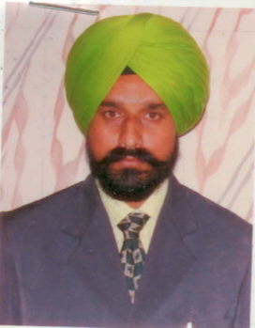

Name : Charanjit Singh

Date of Birth : 20-11-1963

Designation : Instructor

Experience : 1.Instructor(G.N.D.E.C.)(1994 to till date)

Qualifications : 1.Diploma(1990)

2.I.T.I.Electrician(1982)

3.Matric(1980)

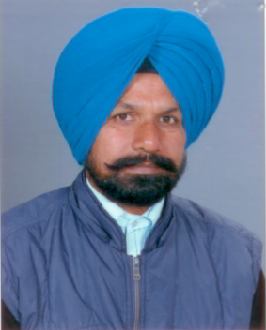

Name : Gurmeet Singh

Date of Birth : 01-04-1966

Designation : Instructor

Experience : 1.About 12 years in Auto Lab.

2.Instructor(G.N.D.E.C.)(1994 to till date)

Qualifications : 1.Diploma in Mech. (1993)

2.Matric (1982)

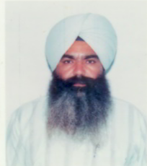

Name : Jasgur Singh

Date of Birth : 01-06-1969

Designation : Sr.Instructor

Experience : 1.Instructor(1994 to till date)

Qualifications : 1.C.T.I.(Fitter)(1991)

2.I.T.I.(Fitter)(1987)

3.Matric(1985)

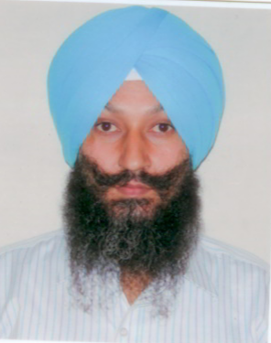

Name : Sukhpal Singh

Date of Birth : 07-09-1972

Designation : Instructor

Experience : 1.Instructor(G.N.D.E.C)(2002 to till date)

Qualifications : 1.Diploma(1992)

2.Matric(1988)



Name : Amritpal Singh

Date of Birth : 20-07-1975

Designation : Instructor

Experience : 1.Instructor(G.N.D.EC.)(20.12.2002 to

till date)

2.Instructor(G.N.D.E.C.)(2001-2002)

3.Industrial Exp.(1997-2001)

Qualifications : 1.1 yr.Diploma in Comp.Aided & Tool

Design(2001)

2.Post diploma in Automobile & Tractor

Engg.(1997)

3.Diploma(1996)

4.Matric(1991)

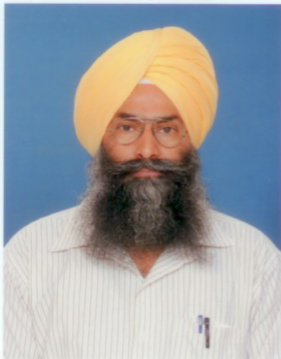

Name : Varinder Singh

Date of Birth : 31-5-1960

Designation : Instructor

Experience : 1.Instructor(G.N.D.E.C.)(2002 to till date)

2.Tech.officer at STEP(G.N.D.E.C.)

(1995-2002)

3.Maint.Engg./Incharge Tool Room at

G.N.A.Goraya(1989-1995)

4.Engg.at J.S.Mech.Works,Krishna Nagar,

Ldh.(1987-1989)

5.Auto Genns(India)38-R,IAB,LDH

(1981-1987)

Qualifications : 1.Diploma Mech.(1987)

2.Matric(1977)

3.Advance Trg.in Latest Welding Techniques.

From L & T,New Delhi.

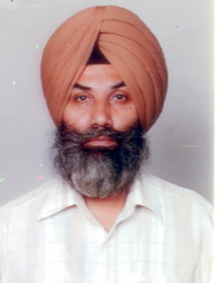

Name : Rajinder Singh

Date of Birth : 15-10-1960

Designation : Instructor

Experience : 1.Instructor(G.N.D.EC.)(2003 to

till date)

2.Instructor(Sukhmani Inst.)(2000-2003)

3.Indian Air Force.(1979-1999)

Qualifications : 1.B.A.(1999)

2.Diploma(1986)

3.Matric(1977)

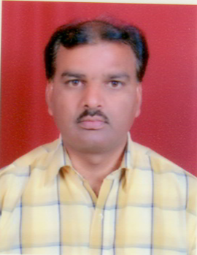

Name : Balwant Raj

Date of Birth : 30-03-1969

Designation : Instructor

Experience : 1.Instructor(G.N.D.EC.)(2003 to

till date)

2.Industrial experience(1988-2003)

In G.N.A.Udyog Ltd.Jalandhar

3.Auto CAD-2D and 3D

Qualifications : 1.Diploma(1988)(3 yr.diploma Mech.Engg.)

3.Matric(1985)

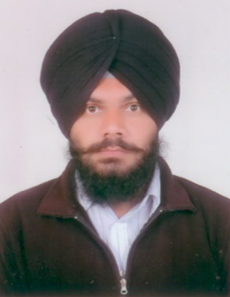

Name : Kuljit Singh

Date of Birth : 17-10-1983

Designation : Instructor

Experience : 1.Instructor(G.N.D.EC.)(2008 to

till date)

Qualifications : 1.Diploma in Electronics & Communication

Engg.(2004)

2.10+2 Arts(2002)

3.Matric(2000)

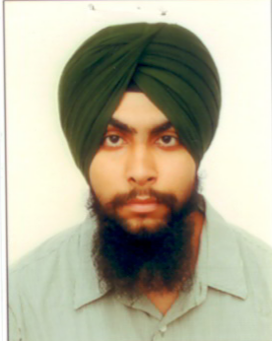

Name : Paviter Singh Grewal

Date of Birth : 28-09-1988

Designation : Instructor

Experience : 1.Instructor(G.N.D.EC.)(since 2nd Aug.2010 )

2.Instructor(Bhutta College of engg.& Tech.)

(July 2009 to July 2010)

3.Industrial exp.July 2008 to June 2009)

Qualifications : 1.Diploma in Mech.Engg.(2005-08)

2.Matric(2005))

Name : Jantinder Singh 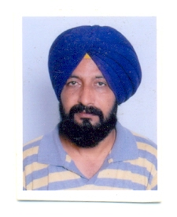

Date of Birth : 21-03-1963

Designation : Instructor

Experience : 1. M/s Dhillon Enterprises( 1986-1990)

2.M/s Sakshi International

3.Generator Operator-cum-Mechanic

(26- 11-2009 to 31-07-12)

4. Instr.01-08-12 till date GNDEC,Ldh.

Qualifications : 1.Diploma in Mech.Engg.(1990)

2.Short term Diploma-Heat Treatment

3.Short term Diploma Matrology&Inspection

4.Matric(1986)